Master:

Node:

Ansible commands:

sudo amazon-linux-extras install epel

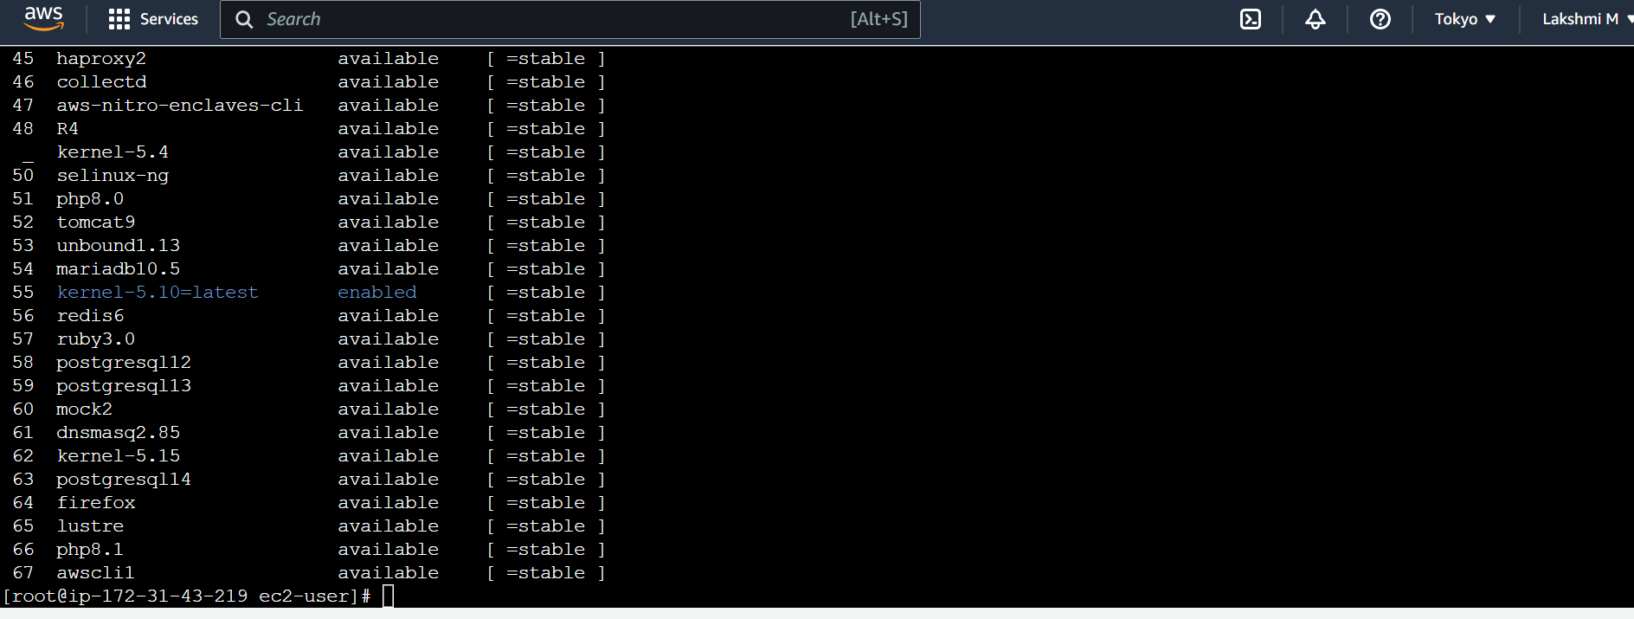

sudo yum install ansible -y

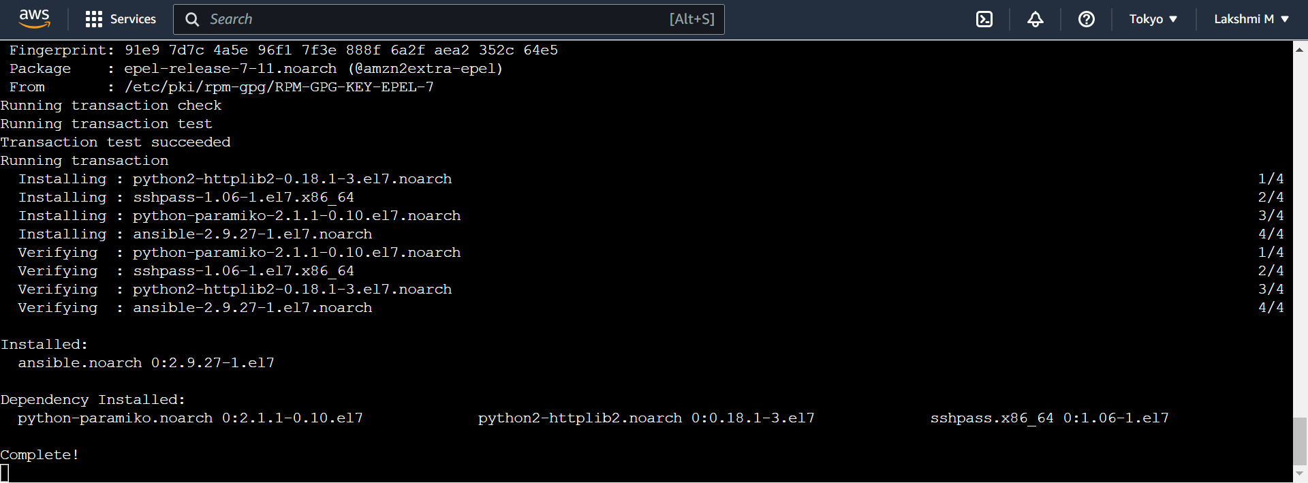

ansible –version

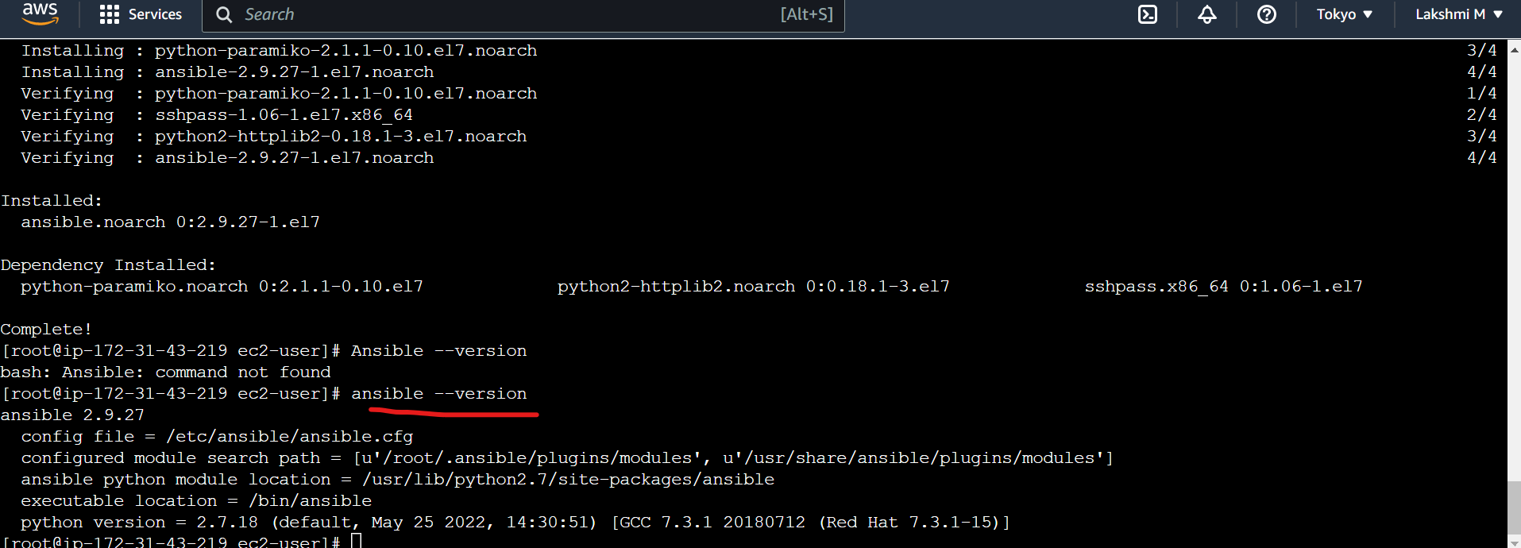

Sudo yum install git -y

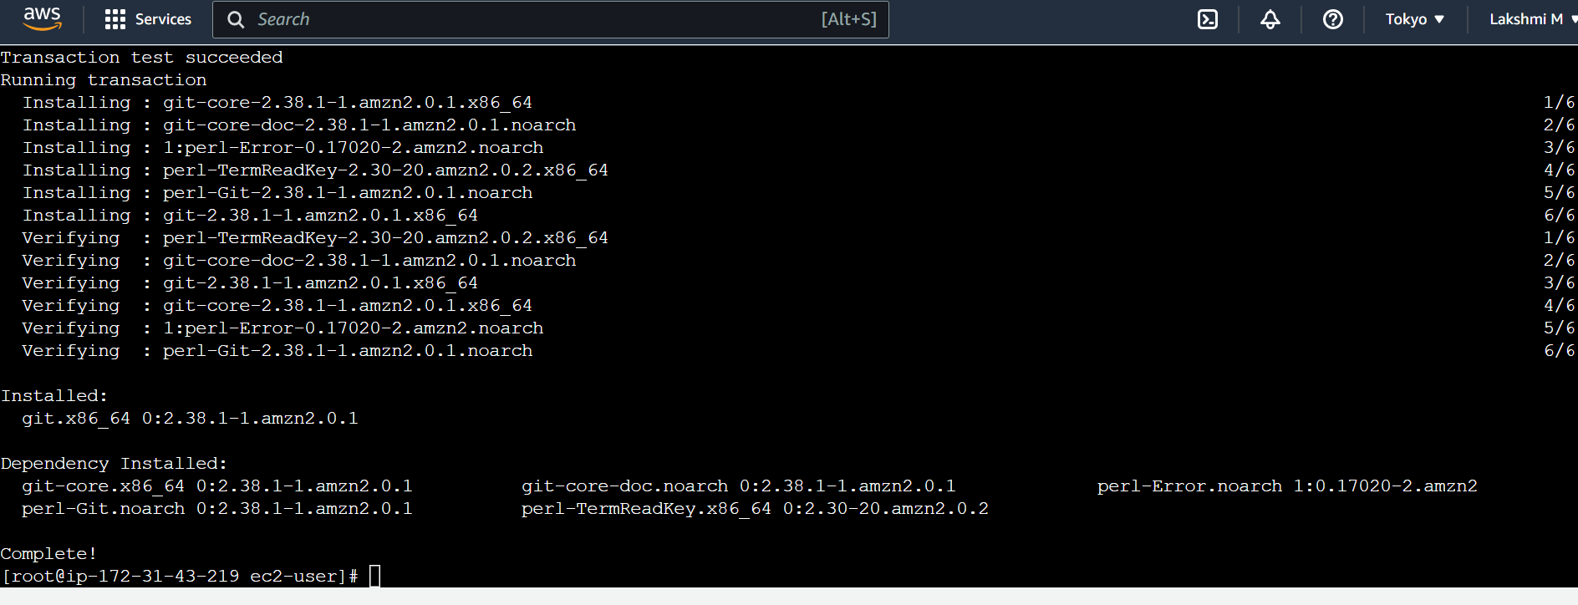

sudo yum install docker -y

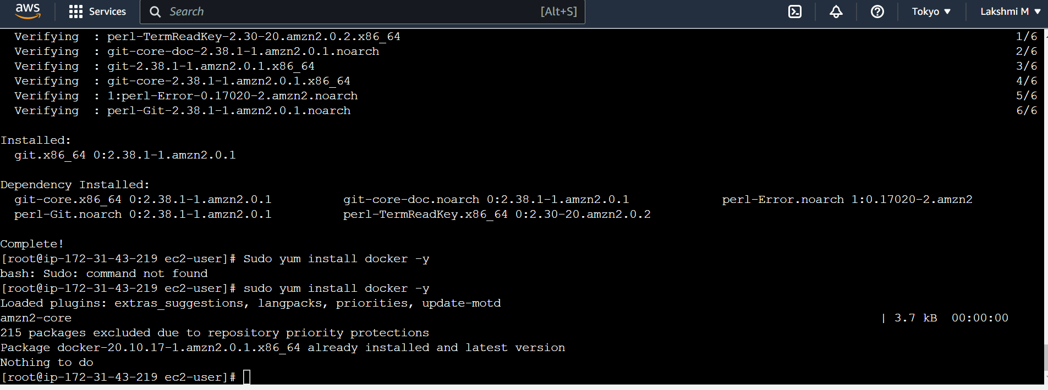

git –version

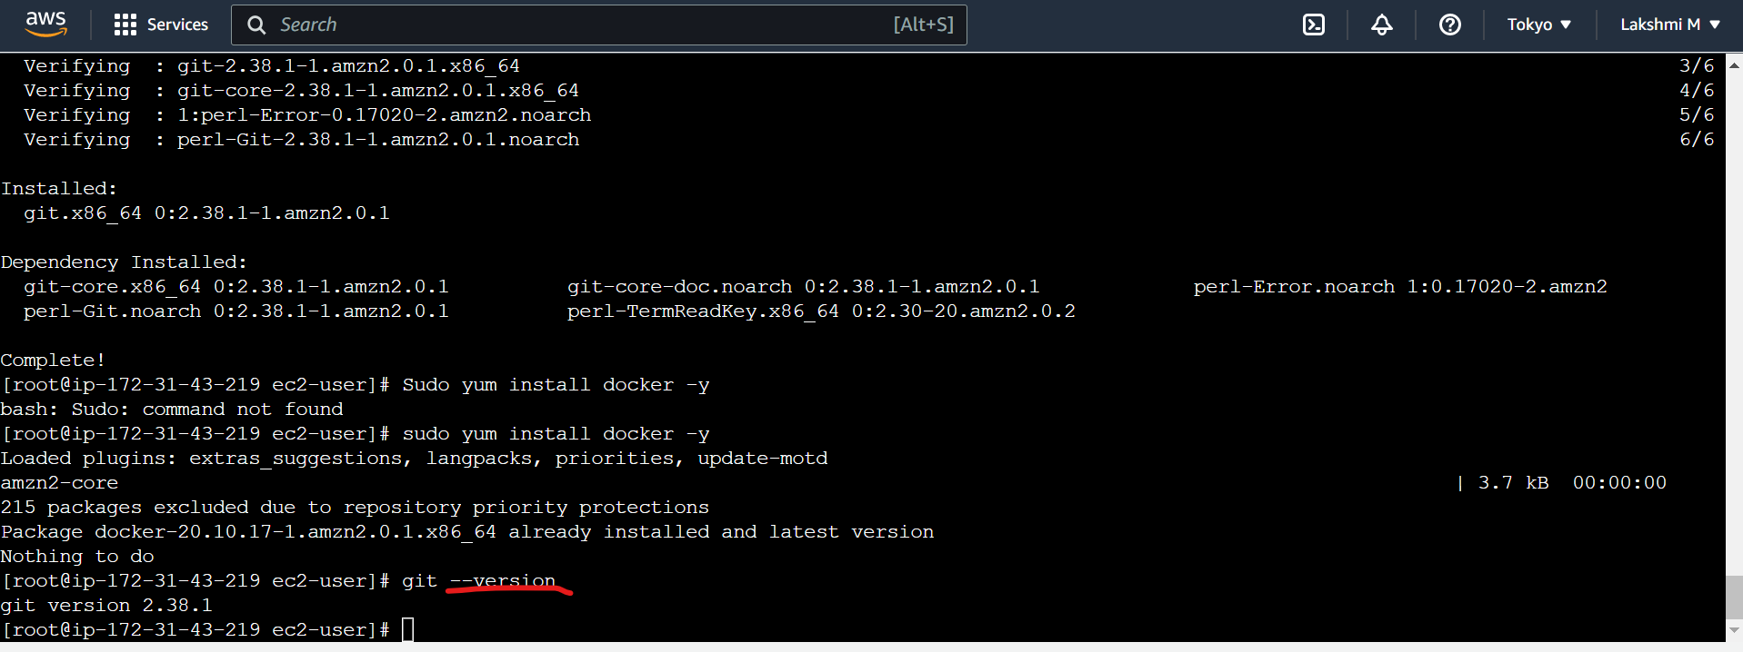

Go back to ec2 user from root user

cd .ssh

ls

ssh key-gen

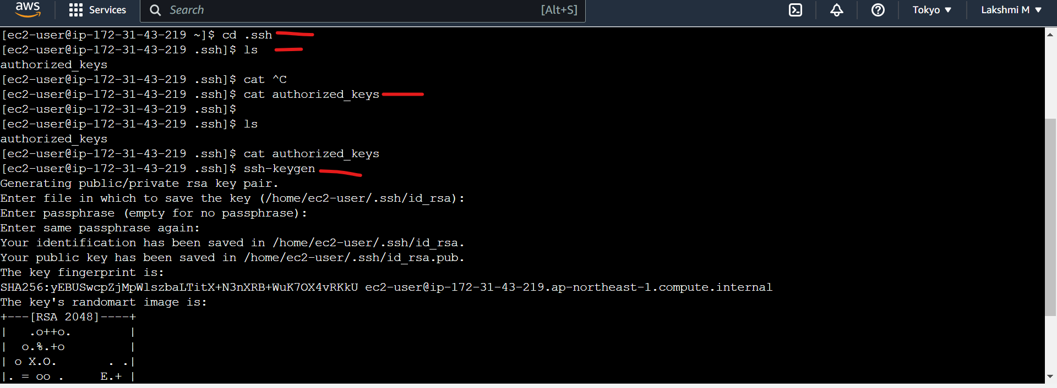

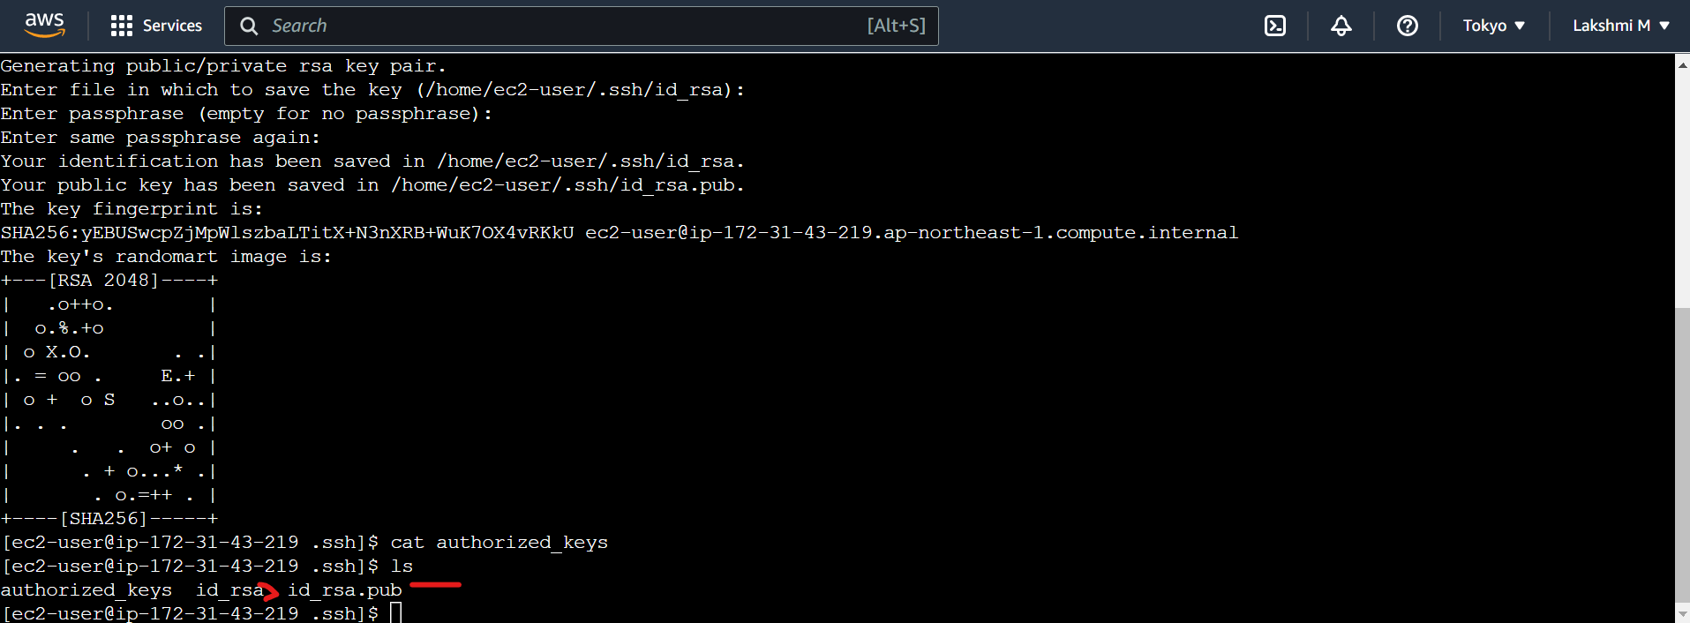

Go to node now

I am using putty here for node:

Use the same commands for key generation

Go to master now:

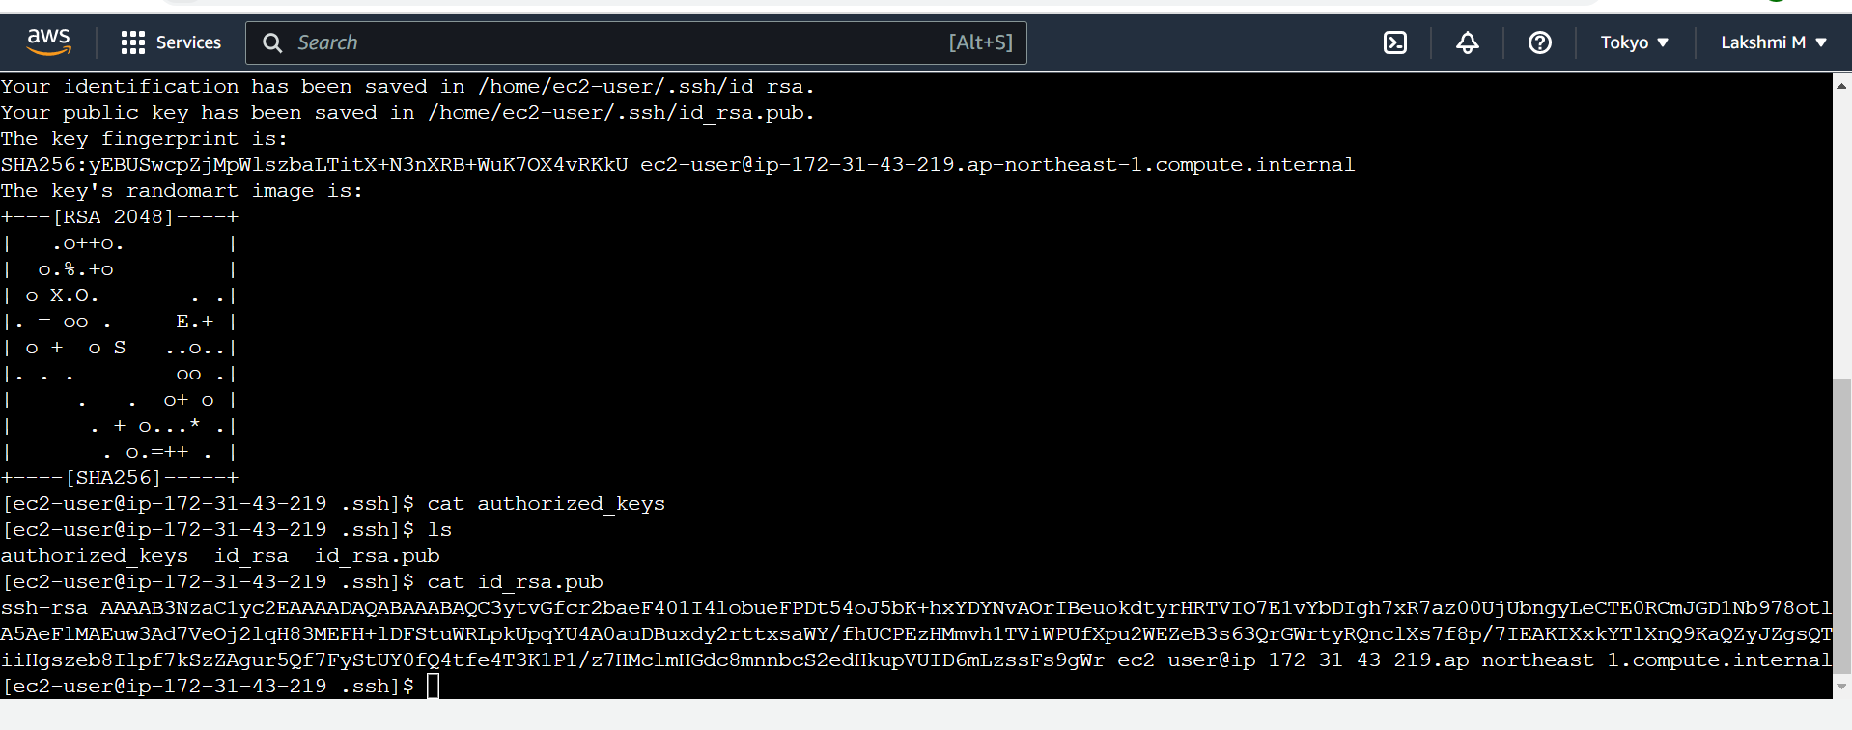

Copy the key from master above one.

Go to Node now

vi authorized_keys

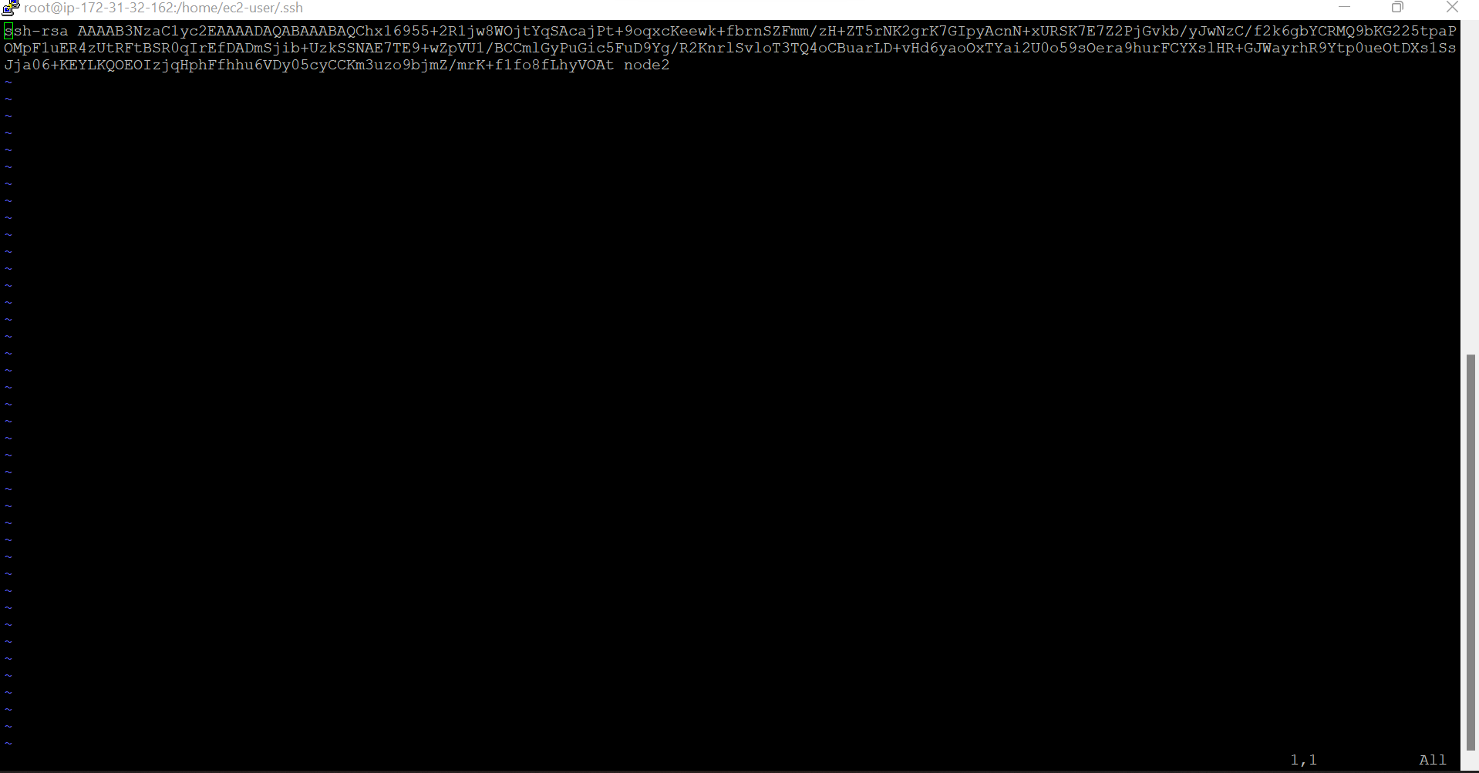

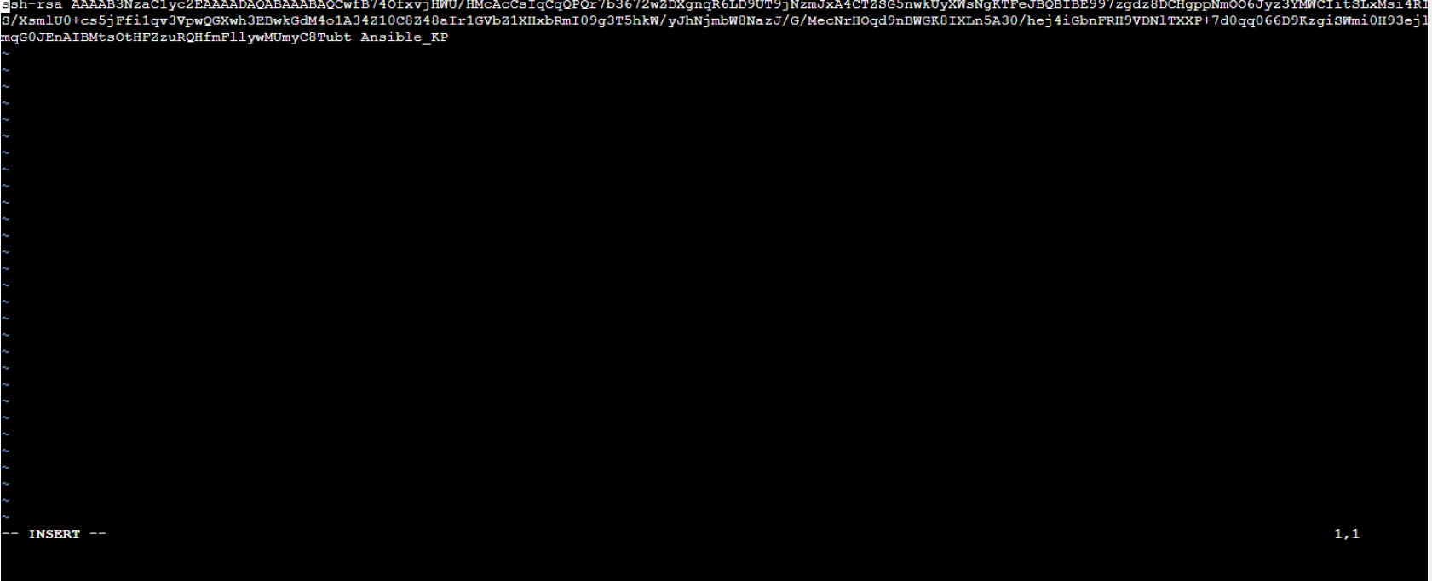

Master Node now:

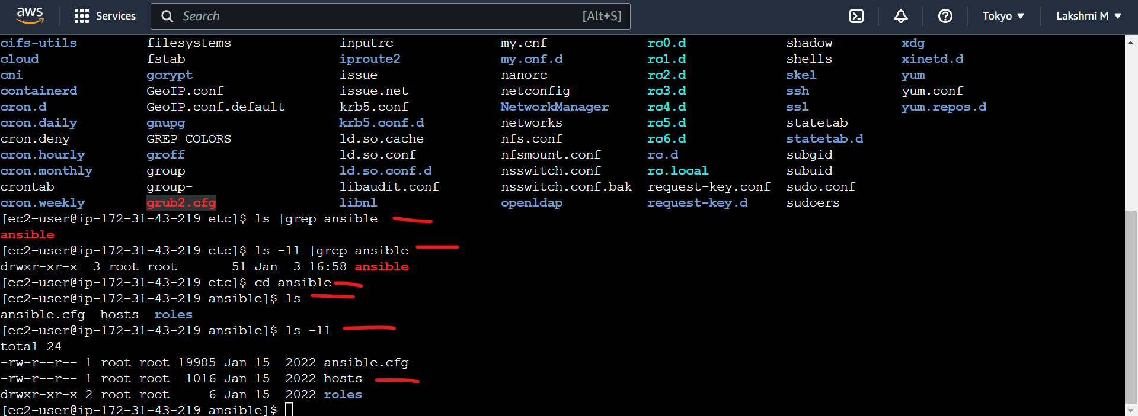

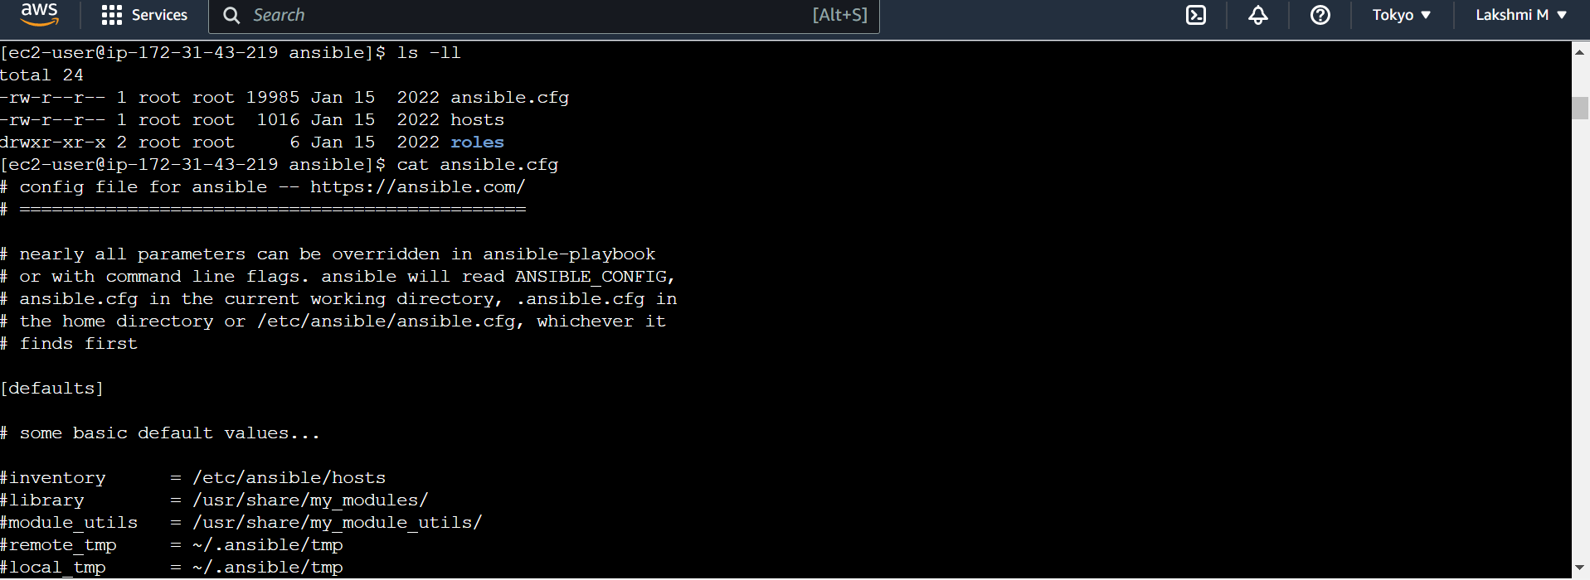

Take the node 2 IP address

Now it is pointed to node

Close and reopen the master node

ansible all -m yum -b -a “name=git”

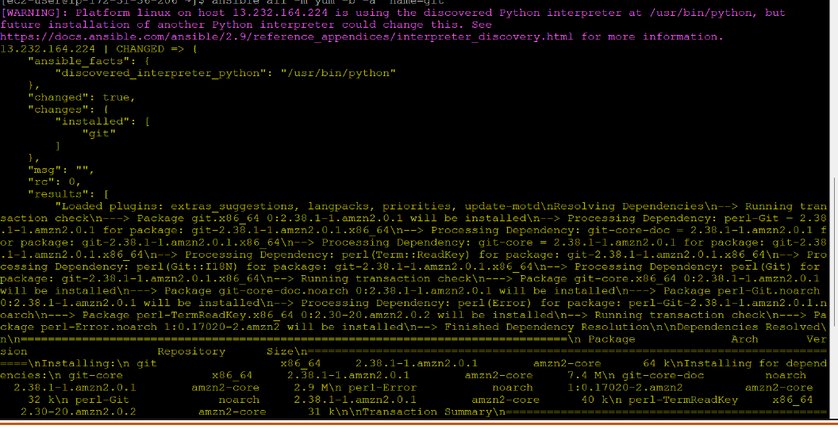

Now check git in node:

